Request to Access Print Material in Library System via Curbside Pickup

Please consult with a librarian prior to completing this form. Submit the completed form to the Associate Dean in your faculty for approval. Associate Dean contact information is included below the form.

Principal Investigator/Faculty Supervisor Information
Name:
Date Submitted:
Department/Unit/School: | Faculty:
Cell Phone (for emergency contact): | Email:
Contact information for all team members requiring access to campus for curbside pick up of print library materials. Add rows as needed.

Name:
Department/Unit/School:
Cell Phone (for emergency contact):
Email:
Status (Principal Investigator/faculty/post-doctoral fellow/graduate student/staff):
Provide rationale for requesting an exemption by briefly addressing the time sensitivity or critical nature of the research requiring access to print materials, and why the research cannot be completed remotely using online information resources (300 words max):
Specific print materials being requested from library.
List print items being requested in priority order by adding permalinks from the library’s Omni search tool. Instructions for finding permalinks are posted at the bottom of this form. Library staff are available to assist if you have any questions. Number of items retrieved will be limited by the library’s capacity to safely retrieve and provide access to materials.

Library staff consulted:
Name of library staff consulted about your information resource need. A list of subject librarians is available at library.queensu.ca/about-us/directory/subject-librarians.

Signature of Principal Investigator/Faculty Supervisor:
Image of signature, e-signature, email attachment with faculty supervisor’s approval, printed and scanned forms with signatures are all valid.

X

Principal Investigator/Faculty Supervisor Date

Send this form to the Associate Dean in your faculty for review.

Contact Information for Associate Dean (Research) Queen's University
Name | Title | Email | Faculty
Nick Mosey | Associate Dean (Research) | moseyn@queensu.ca | Arts and Science
Amir Fam | Associate Dean (Research) | amir.fam@queensu.ca | Engineering and Applied Science
Theodore Christou | Associate Dean Graduate Studies & Research | theodore.christou@queensu.ca | Faculty of Education
Yolande Chan | E. Marie Shantz Professor of IT Management and Associate Dean (Research) | ychan@queensu.ca | Smith School of Business
Joshua Karton | Associate Dean, Graduate Studies and Research | joshua.karton@queensu.ca | Faculty of Law
Steven Smith | Vice-Dean Research | sps1@queensu.ca | Faculty of Health Sciences

Additional steps will be completed by the Associate Dean and Library and you will be contacted with a response as soon as possible

Approvals

Associate Dean and Library signatures will be added during the review and approval process.

X

Associate Dean approval Date

Additional comments from Associate Dean (Resaerch), if needed.

X

Library approval Date

Additional comments from Faculty Dean (or delegate), if needed.
Indicate priority rating (1, 2 or 3) per the Queen’s Research and Facility Start-up Planning document, and briefly explain rationale for rating:

Using Omni to capturing a permalink
Use the Omni search box on the library’s homepage (library.queensu.ca) to search for the print material you wish to request. Help and support for using Omni is available on the library’s website (library.queensu.ca/search/omni) including contact information if assistance is needed.

- Search for item in Omni (e.g.: Curious incident of the dog in the night time)
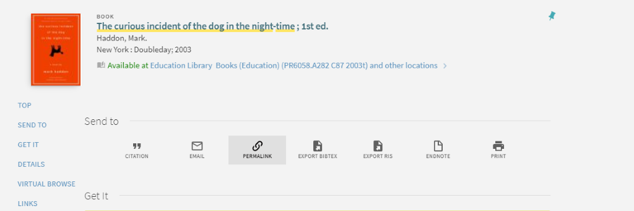
- Click on title of desired item, and select “permalink” in resulting screen
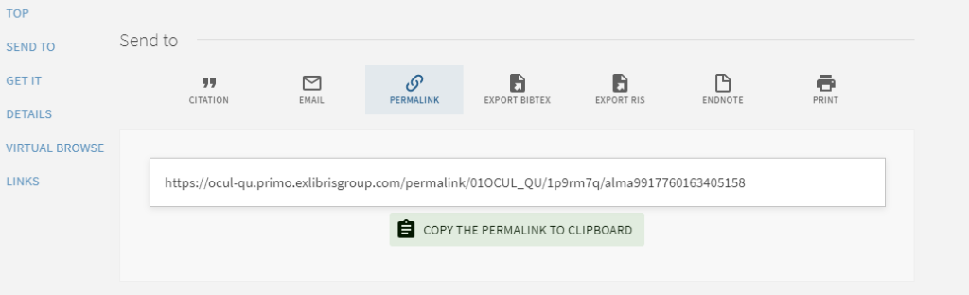
- Copy permalink and paste it into field in request form

